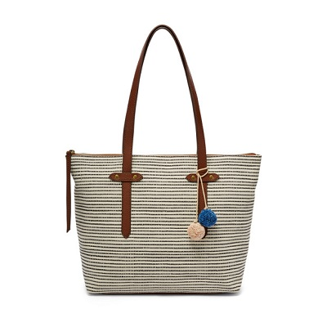

Felicity Tote

PRODUCT DETAILS

**Silhouette: Tote**

**Tech Compatibility: iPhone® 6 Plus, iPhone® 7 Plus, iPhone® 8 Plus**

**Exterior Material: 57% Jute, 43% Cotton/PVC Trim**

**Interior Details: 1 Zipper Pocket, 2 Slide Pockets, 1 Pen Holder**

**Measurements: 15.38"L x 4.75"W x 11"H**

**Handles/Straps: 2 Handles**